**Aim:** Case Study: Analysis of the Shark Tank US dataset

**IDE:** R Studio

**Dataset:**

Download the dataset of Shark Tank US from kaggle. Link of dataset:

https://www.kaggle.com/datasets/thirumani/shark-tank-us-dataset/download?datasetVersionNumber=17

**Program:**

Write R script code and perform the following analysis:

1. Which season is having the overall highest deal in terms of the amount?
2. Enlist episodes for each season having the highest deal in terms of the amount?
3. Which are the top-10 deals in the shark tank?
4. Top-3 Industries with highest deals in the shark tank?
5. Which are the top-5 cities with the maximum number of entrepreneurs?
6. Which are the top-3 states that has got maximum number of deals?
7. Industry wise count the total number of startups who pitched in shark tank
8. Count the number of pitchers who are male, female and belongs to mixed team
9. Find the maximum amount requested by a pitcher in each industrial segment
10. Find the maximum equity received by a shark in each industrial segment
11. Find the total amount invested by each shark throughout shark tank
12. Name the startups with Top-15 investments
13. Find number of deals having [1,2,3,4,5] sharks included in the deal
14. Which are the top-3 industries where "Kevin O Leary" is more interested to invest into?
15. Which are the 3 least favoured industries by the sharks?

Required Functions:-

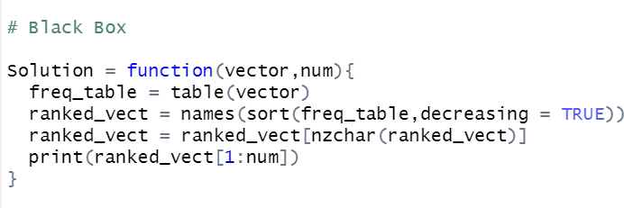

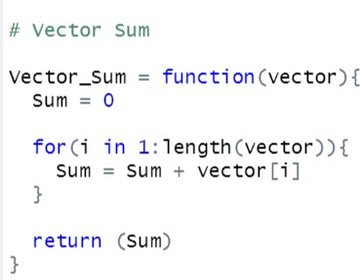



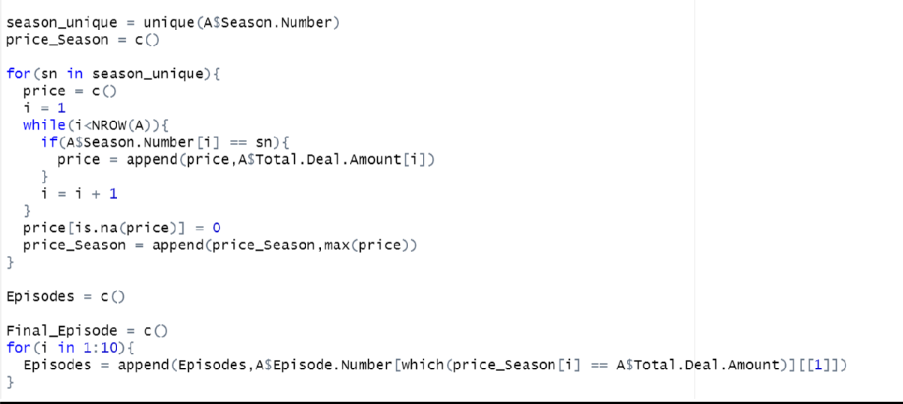

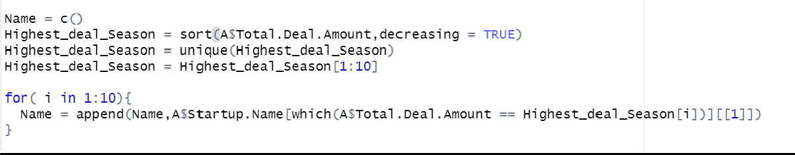

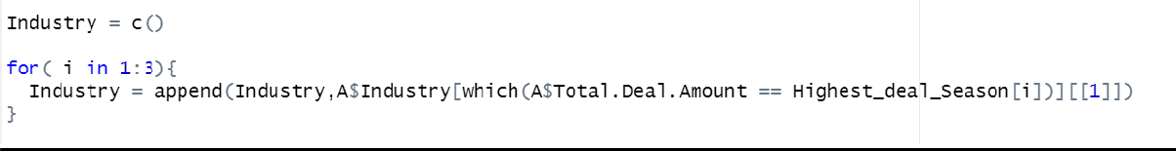

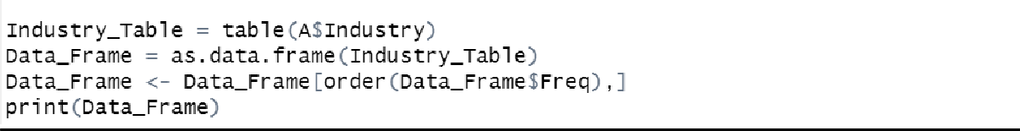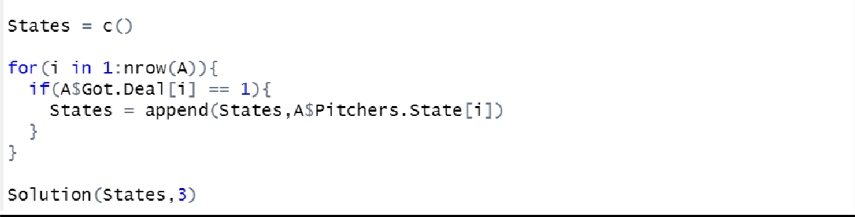

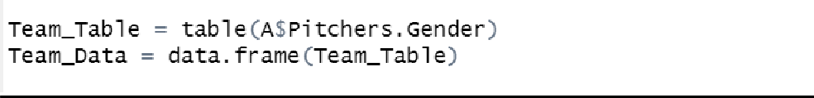

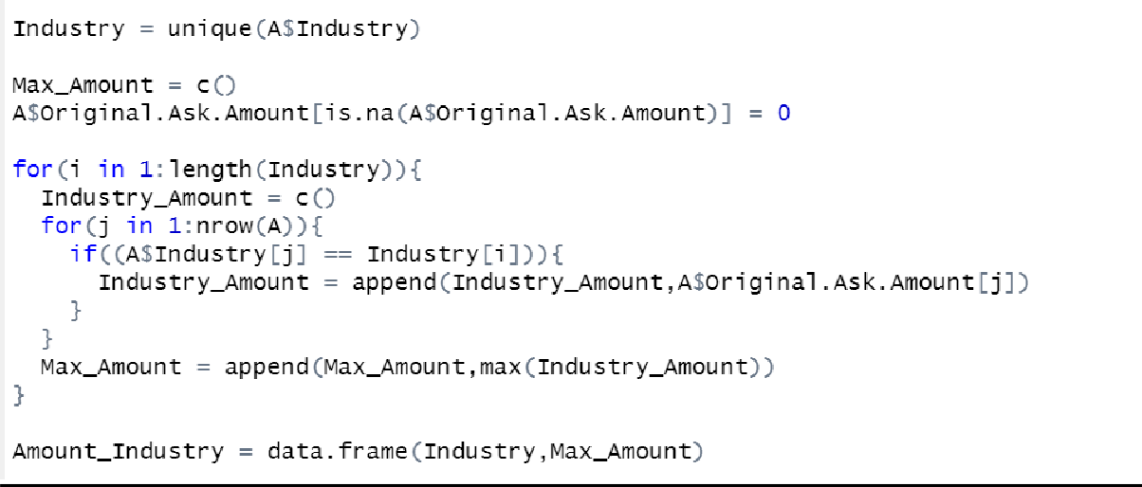

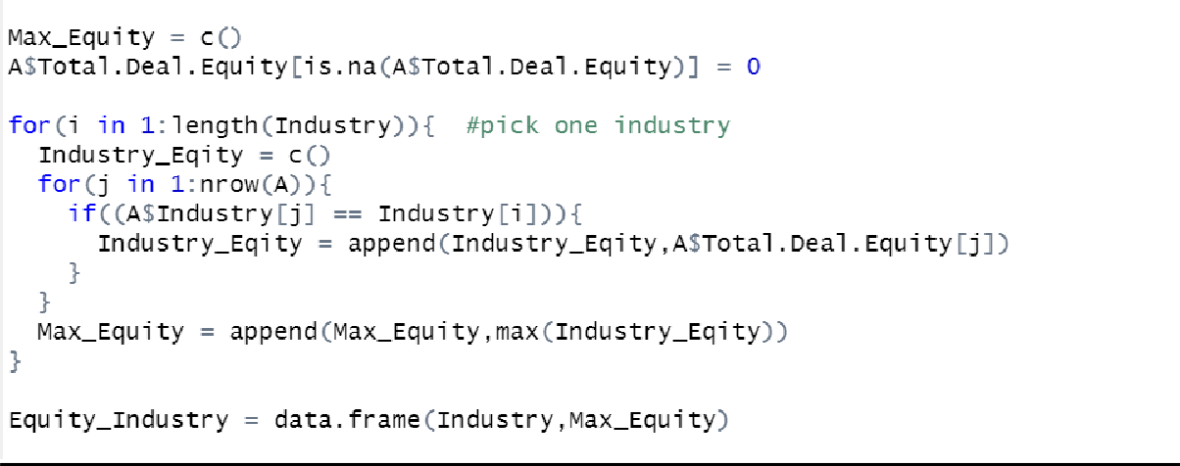

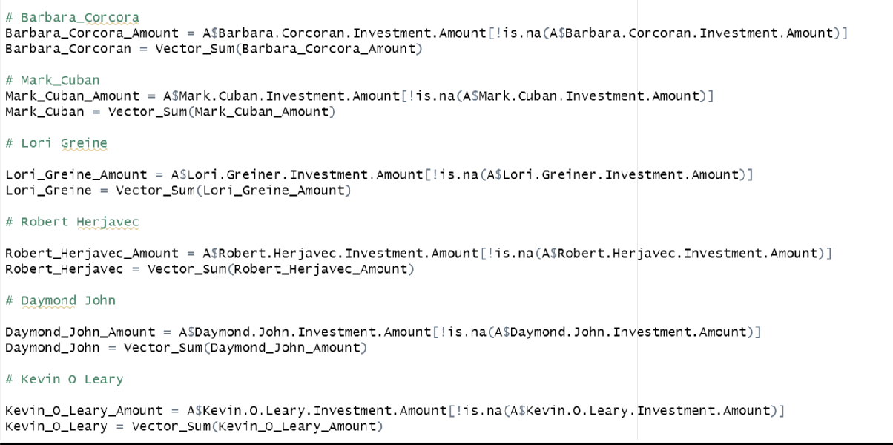



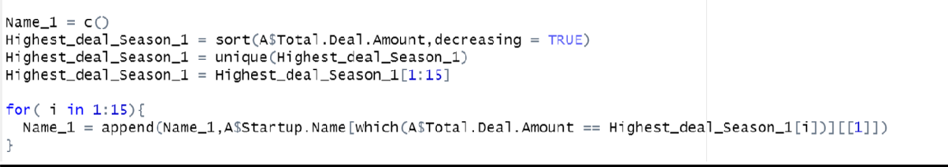

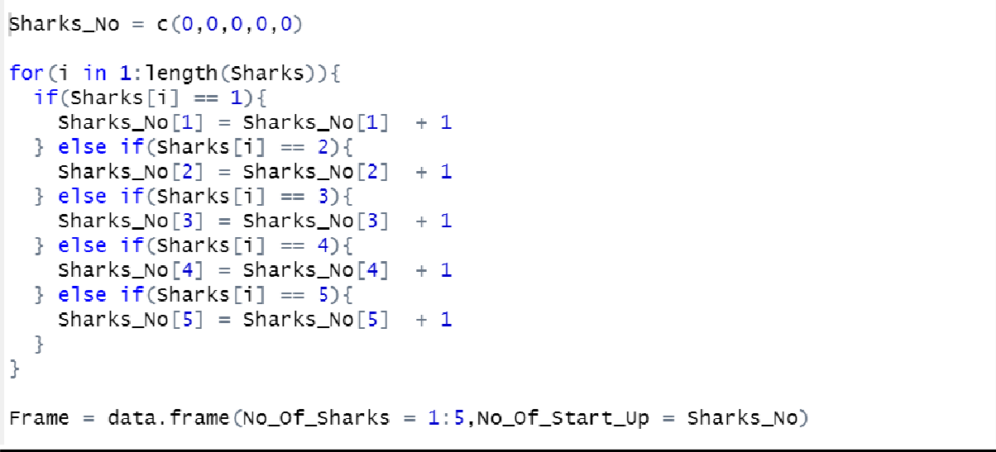

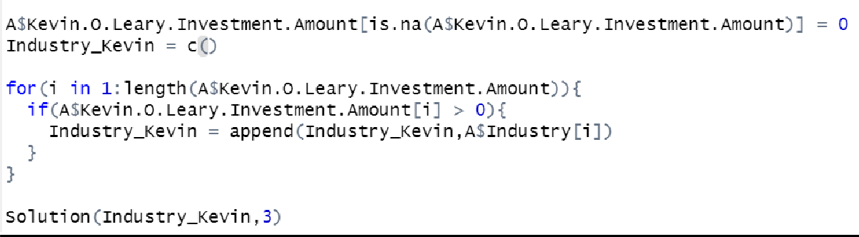

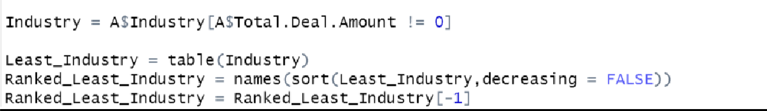

**Output:**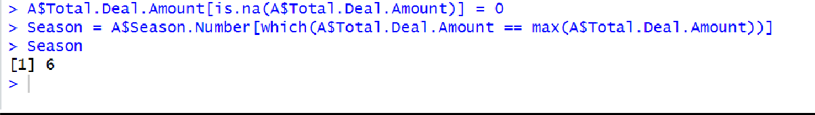

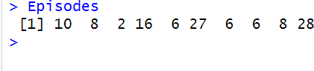

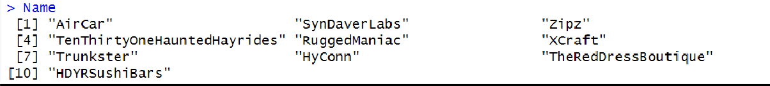







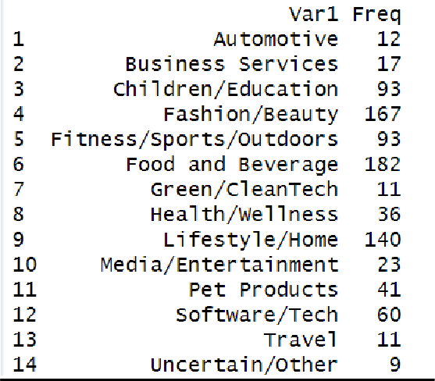

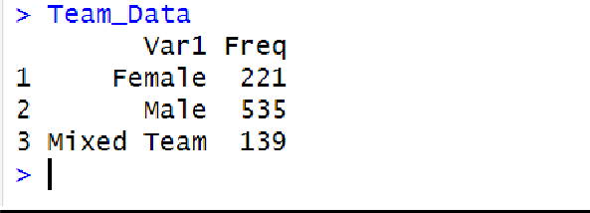

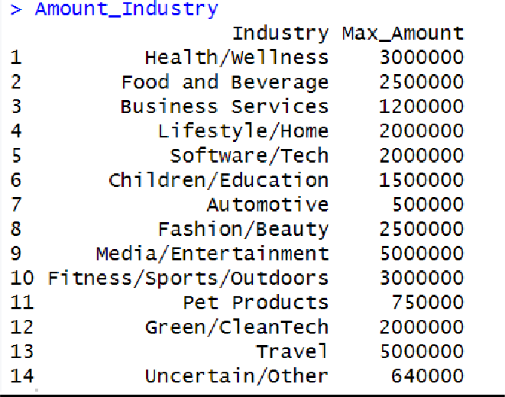

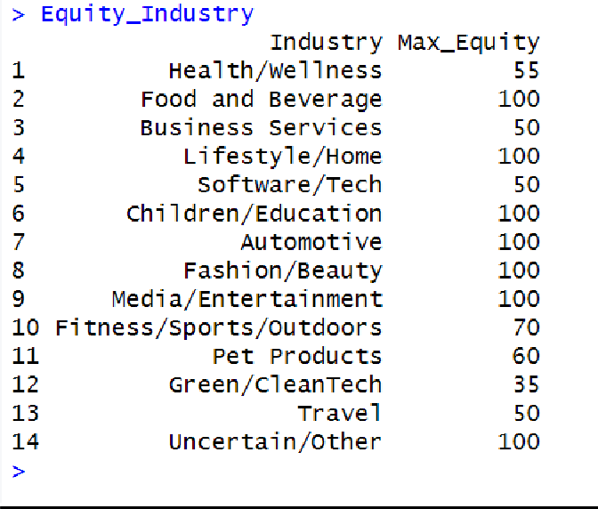

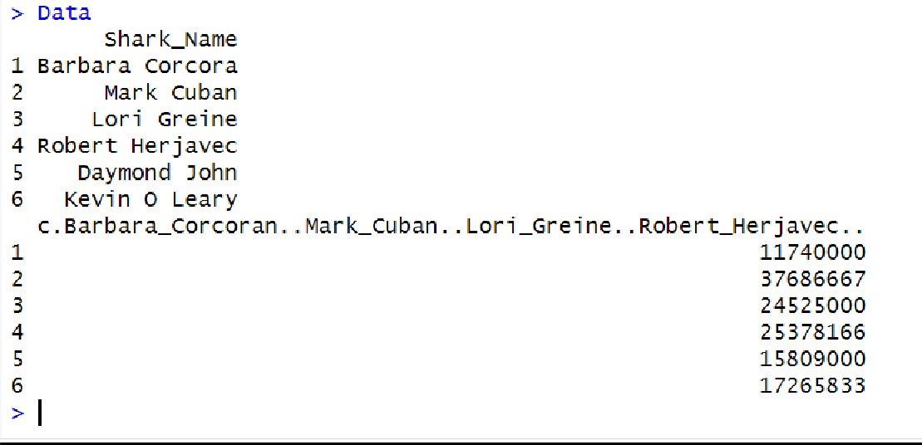

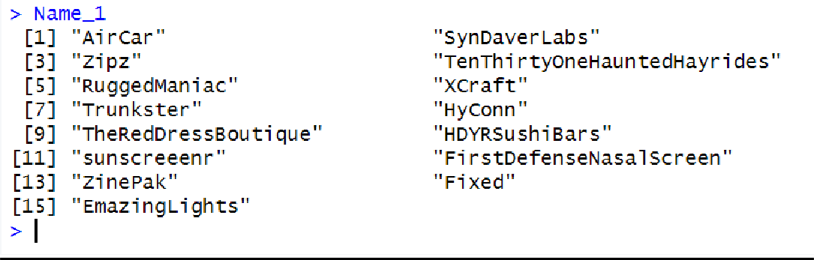

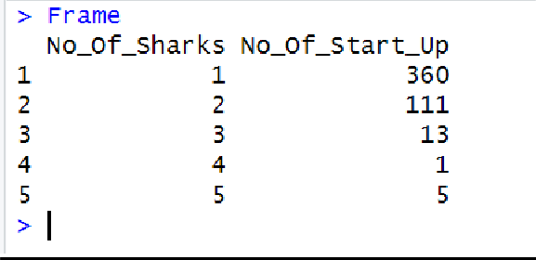



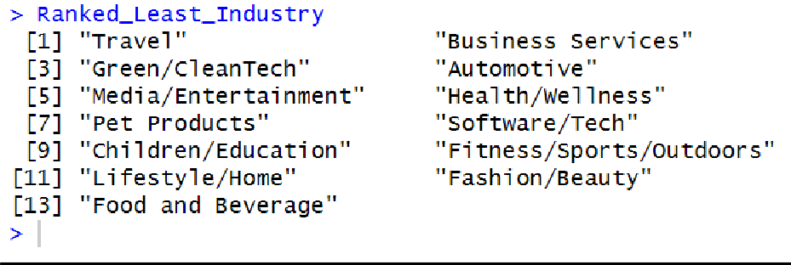

**Observation and Learnings:**

1. Explain the dataset

________________________________________________________________________________________________________________________________________________________________________________________________________________________________________________________________________________________________________________________________________________________________________________________________________________________________________________________________________________________________________________________

1. Write your answer and your inference for each of the questions mentioned in “Program” section